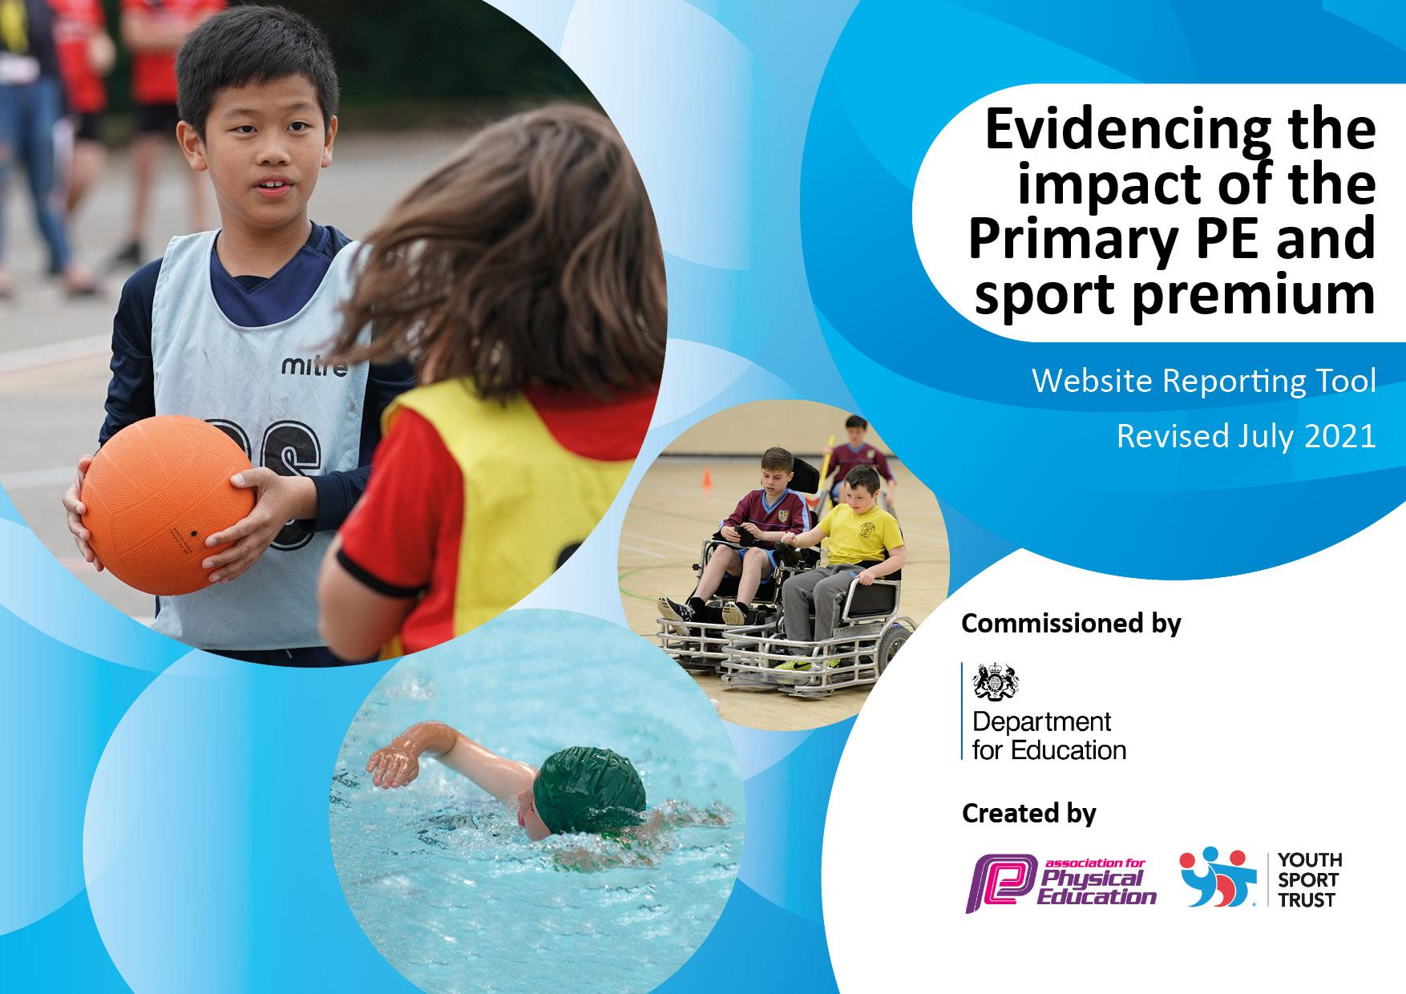
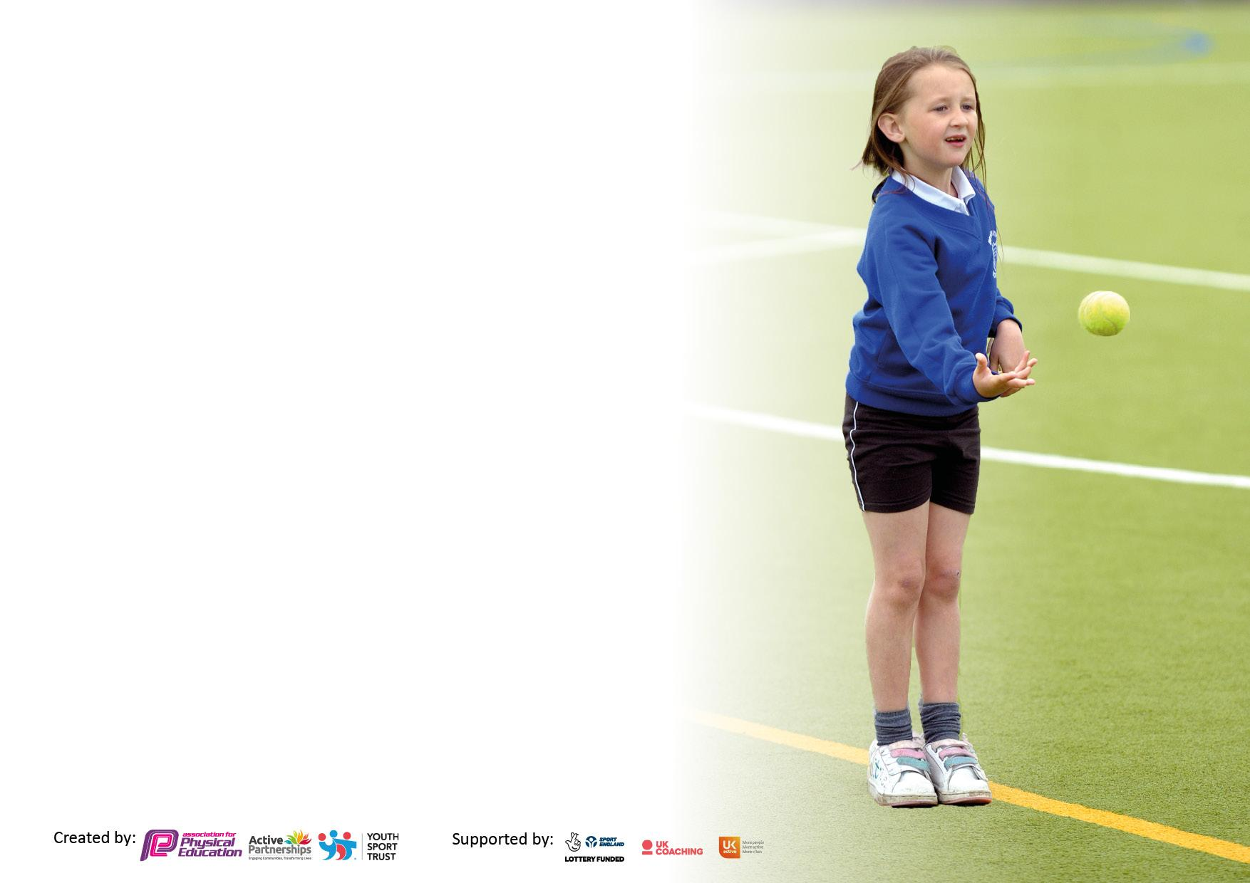

It is important that your grant is used effectively and based on school need. The Education Inspection Framework makes clear there will be a focus on ‘whether leaders and those responsible for governors all understand their respective roles and perform these in a way that enhances the effectiveness of the school’.

Under the Quality of Education Ofsted inspectors consider:
Intent - Curriculum design, coverage and appropriateness
Implementation - Curriculum delivery, Teaching (pedagogy) and Assessment
Impact - Attainment and progress

To assist schools with common transferable language this template has been developed to utilise the same three headings which should make your plans easily transferable between working documents.

Schools must use the funding to make additional and sustainable improvements to the quality of Physical Education, School Sport and Physical Activity (PESSPA) they offer. This means that you should use the Primary PE and sport premium to:

- Develop or add to the PESSPA activities that your school already offer
- Build capacity and capability within the school to ensure that improvements made now will benefit pupils joining the school in future years
- The Primary PE and sport premium should not be used to fund capital spend projects; the school’s budget should fund these.

Pleasevisitgov.ukfortherevisedDfEguidanceincludingthe5keyindicatorsacrosswhichschoolsshoulddemonstrate animprovement.Thisdocumentwillhelpyoutoreviewyourprovisionandtoreportyourspend.DfEencouragesschools to use this template as an effective way of meeting the reporting requirements of the Primary PE and sport premium.

We recommend you start by reflecting on the impact of current provision and reviewing the previous spend.

Schools are required to publish details of how they spend this funding, including any under-spend from 2019/2020, as well as on the impact it has on pupils’ PE and sport participation and attainment. All funding must be spent by 31st July 2022.

We recommend regularly updating the table and publishing it on your website throughout the year. This evidences your ongoing self-evaluation of how you are using the funding to secure maximum, sustainable impact. Final copy must be posted on your website by the end of the academic year and no later than the 31st July 2021. To see an example of how to complete the table please click HERE.

Details with regard to funding
Please complete the table below.

Total amount carried over from 2019/20 | ££4,762.50 (SPENT – Amy HQ)
Total amount allocated for 2020/21 | £ £16,000 (+£10 per child)
How much (if any) do you intend to carry over from this total fund into 2021/22? | £ 12,381
Total amount allocated for 2021/22 | £ £16,000 (+£10 per child)
Total amount of funding for 2021/22. To be spent and reported on by 31st July 2022. | £ 28, 451 (to go towards 2 PE active leads on MPS)

Swimming Data
Please report on your Swimming Data below.

Meeting national curriculum requirements for swimming and water safety.  N.B. Complete this section to your best ability. For example you might have practised safe self-rescue techniques on dry land which you can then transfer to the pool when school swimming restarts.  Due to exceptional circumstances priority should be given to ensuring that pupils can perform safe self rescue even if they do not fully meet the first two requirements of the NC programme of study | Swimming to resume Sep 21. Years 4/5 and top up for Y6 who have not met requirements.  Water safety taking place – through Oakwood academy - virtual  Joined swimming.org charter to support planning and awards system. £100
What percentage of your current Year 6 cohort swim competently, confidently and proficiently over a distance of at least 25 metres?  N.B. Even though your pupils may swim in another year please report on their attainment on leaving primary school at the end of the summer term 2020.  Please see note above | %
What percentage of your current Year 6 cohort use a range of strokes effectively [for example, front crawl, backstroke and breaststroke]?  Please see note above | %
What percentage of your current Year 6 cohort perform safe self-rescue in different water-based situations? | %
Schools can choose to use the Primary PE and sport premium to provide additional provision for swimming but this must be for activity over and above the national curriculum requirements. Have you used it in this way? | Yes/No (Top up Y6)

Action Plan and Budget Tracking
Capture your intended annual spend against the 5 key indicators. Clarify the success criteria and evidence of impact that you intend to measure to evaluate for pupils today and for the future.

Academic Year: 2021/22 | Total fund allocated:  £ 28, 451 | Date Updated: Sep 2021
Key indicator 1: The engagement of all pupils in regular physical activity – Chief Medical Officers guidelines recommend that primary school pupils undertake at least 30 minutes of physical activity a day in school |  |  |  | Percentage of total allocation:
 |  |  |  | %15
Intent | Implementation |  | Impact
Your school focus should be clear what you want the pupils to know and be able to do and about  what they need to learn and to  consolidate through practice: | Make sure your actions to achieve are linked to your intentions: | Funding allocated: | Evidence of impact: what do pupils now know and what can they now do? What has changed?: | Sustainability and suggested next steps:
Whole school focus on ALL children being physically active for at least 30 mins every day. Regular physical activity to increase alertness and the positive impact upon health and wellbeing | - Continue to implement whole school daily exercise, mile of the day  - Termly challenges (skipping, catching, jumping etc) suggestions from children after first challenge  - Playleader training  - Bikeability training  - Road safety training | £ 1500  10% of active lead role / cost | pupil voice noted, new equipment purchased, playtime and lunchtime active  challenges set and children responding  well being leads - use to initiate and ensure all are included  February 2022
Increase daily physical activity for less active children to promote the importance of leading a healthy and active lifestyle | - Development of active learning opportunities across curriculum (active Maths / English etc)  - Use of data to identify who we need to develop activity levels  - Identify children who are not engaging in after school activities and invite directly to after school clubs and engage with parents | Active maths and English  £1000  Part of active lead role | Active maths and Active English used weekly by class teacher and active learning teacher  Individual children approached re after school activities to engage them - February 2022
Key indicator 2: The profile of PESSPA being raised across the school as a tool for whole school improvement |  |  |  | Percentage of total allocation:
 |  |  |  | %45
Intent | Implementation |  | Impact
Your school focus should be clear what you want the pupils to know and be able to do and about  what they need to learn and to  consolidate through practice: | Make sure your actions to achieve are linked to your intentions: | Funding allocated: | Evidence of impact: what do pupils now know and what can they now do? What has changed?: | Sustainability and suggested next steps:
Engagement with physical activities to contribute towards whole school improvement by engaging children across the curriculum positively impacting behaviour and attainment | - Active maths / English  - Running of interventions - through an active means to impact on pupils progress and attainment in core subjects.  - Participation in ASPIRE Cup  - Sports Week to promote leading healthy and active lifestyle, raising profile of PE and sport through various curriculum subjects  - Active lunch times  - Each class to have PE book to evidence progression in PE – show planning/success criteria for term, pictures, pupil voice  - School website to be kept up to date with PE information  - PE board in school showing PE values, what children are learning, interactive with children with ideas for clubs etc. | 40% of active lead role / cost  Release time for PE lead  £1000 | Active maths and English used by class teacher, TAs and active learning teacher  Active teacher started January 2022, so progress will be measured for targeted children in April 2022  Active lunchtimes - new equipment - ropes, hopes, balls etc having an impact  PE books in place in each class, clearer evidence of progress  PE information on website and PE board - need actioning  February 2022
Development of cross curricular skills through PE – leadership. Resilience, determination, team work | - Children to engage in peer assessment developing use of key words and correct terms within PE  - Children to develop self-assessment through personal Healthy Living Journal to be completed termly  - Forest school – termly across the year – all year groups to develop teamwork / resilience / leadership skills through Forest Schools. | PE lead support release time £500  £150 to contribute | Vocabulary - action for term 4 - see rolling record from deep dive term 3  Journal started for each child  Forest school - so far year 2,3 have attended - one year group each term to attend  February 2022

Key indicator 3: Increased confidence, knowledge and skills of all staff in teaching PE and sport |  |  |  | Percentage of total allocation:
 |  |  |  | %5
Intent | Implementation |  | Impact
Your school focus should be clear | Make sure your actions to | Funding | Evidence of impact: what do | Sustainability and suggested
what you want the pupils to know | achieve are linked to your | allocated: | pupils now know and what | next steps:
and be able to do and about | intentions: |  | can they now do? What has
what they need to learn and to |  |  | changed?:
consolidate through practice:
Increase confidence, knowledge and skills of all staff in teaching and supporting PE to promote the positive progress of all children | - PE Lead and FS to monitor quality of PE lessons  - PE Lead and FS to monitor effective use of Greenacre Scheme of work  - Audit of teaching staff confidence and knowledge  - PE Lead to implement and monitor effective assessment of children  - Purchase staff PE t-shirt and fleece | Release time  £2000  £1000 | Deep dive - term 3 - see rolling record  New approach to planning - staff training - term 4  February 2022
Key indicator 4: Broader experience of a range of sports and activities offered to all pupils |  |  |  | Percentage of total allocation:
 |  |  |  | 20%
Intent | Implementation |  | Impact
Your school focus should be clear | Make sure your actions to | Funding | Evidence of impact: what do | Sustainability and suggested
what you want the pupils to know | achieve are linked to your | allocated: | pupils now know and what | next steps:
and be able to do and about | intentions: |  | can they now do? What has
what they need to learn and to |  |  | changed?:
consolidate through practice:
Additional achievements:  Provide a broad range of sports and activities to engage all pupils within school ensuring focus upon less active and different groups ( SEN, GRT, PP) | - Employment of whole school active lead to provide lunchtime, intervention and after school clubs  - Audit of existing equipment, replace any broken equipment, buy equipment needed to match PE SOW  - Across ASPIRE - Football club has been asked for | Part of active leads cost  25% of active lead role  Equipment purchased use of rainbow award grant won - £500  £2000 for year | Active learning teacher providing multi skills club after school/ lunch time - on a rolling programme  Active lead has completed audit of equipment - new equipment purchased with rainbow award grant  Football club takes place on a monday after school - premier sports  February 2022

Key indicator 5: Increased participation in competitive sport |  |  |  | Percentage of total allocation:
 |  |  |  | %15
Intent | Implementation |  | Impact
Your school focus should be clear | Make sure your actions to | Funding | Evidence of impact: what do | Sustainability and suggested
what you want the pupils to know | achieve are linked to your | allocated: | pupils now know and what | next steps:
and be able to do and about | intentions: |  | can they now do? What has
what they need to learn and to |  |  | changed?:
consolidate through practice:
To raise participation in competitive sport ensuring that all groups of children have the same opportunities  ALL children given the opportunity to represent their school in inter school competitive sport | - ALL children to participate in ASPIRE cup  - Actively promote and engage children in inter school sports competitions | Release time  £1000  25% of Active leads role / cost | To be reinstated once covid restrictions allow  February 2022

Signed off by
Head Teacher: | Emma Hickling
Date: | 1st October
Subject Leader: | Claire KILLICK
Date: | 27th September
Governor:
Date:

